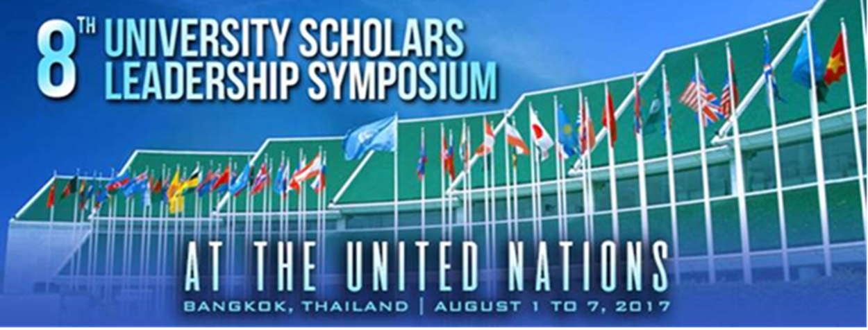

The **8th University Scholars Leadership Symposium 2017** at **United Nations** in Bangkok, Thailand is OPEN for registration !

We are looking for competent and compassionate student leaders with the following qualities to join us in this Leadership Development in Social Change :

1. Student Leaders who have demonstrated strong leadership potential and aspire to constantly learn from others to better themselves.
2. Student leaders who have an open mind and a genuine appreciation for different perspectives and individuals with different backgrounds, interests and ambitions.
3. Student leaders who show consideration for others and possess an interest to better society.

For more information visit our website at [www.universityscholars.org.uk](http://www.universityscholars.org.uk) or simply write in to [lillian.lu@humanitarianaffairs.org](mailto:lillian.lu@humanitarianaffairs.org)

Watch the video from past symposia and be inspired to **TAKE ACTION** !

[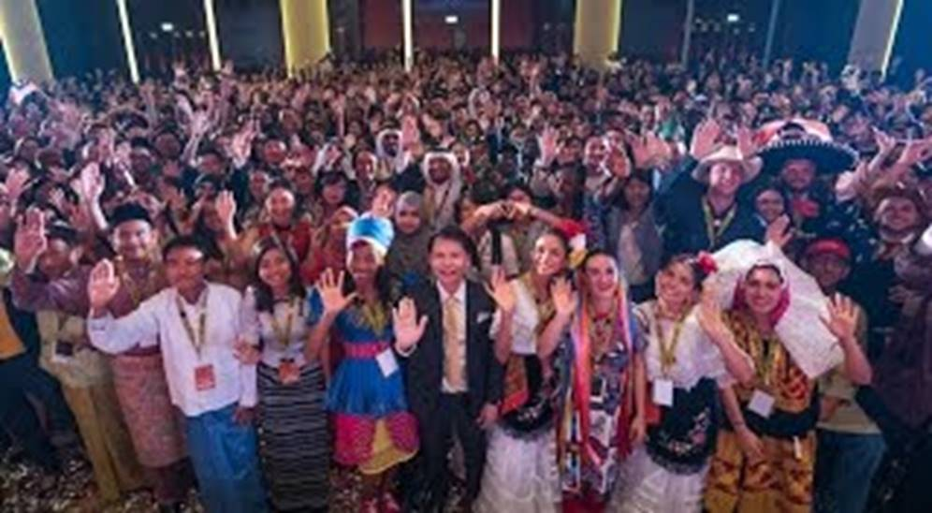](https://www.youtube.com/attribution_link?a=yJ8e6VHc2Eg&u=/watch?v%3DF_n3FfC-yEE%26feature%3Dem-share_video_user)