Subject: [Taiwan Tourism Bureau Activity Section] Scholarship for Foreign Students

Hi,

Taiwan Tourism Bureau Activity Section has delivered a scholarship for foreign students in Taiwan. All you need to do is to share with us of what you see in Taiwan by editing a film and you will have the chance to win the fund of going back to your hometown!

We look forward to your participation!

Please check the followings for more information:
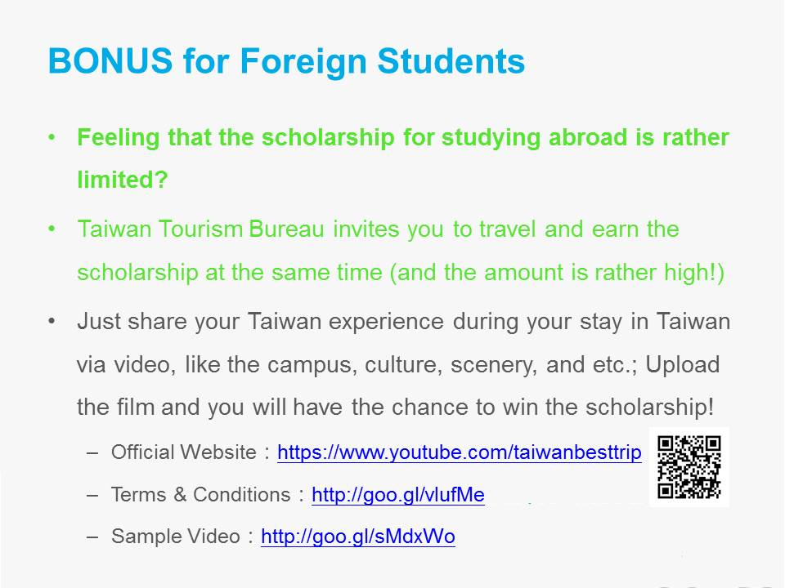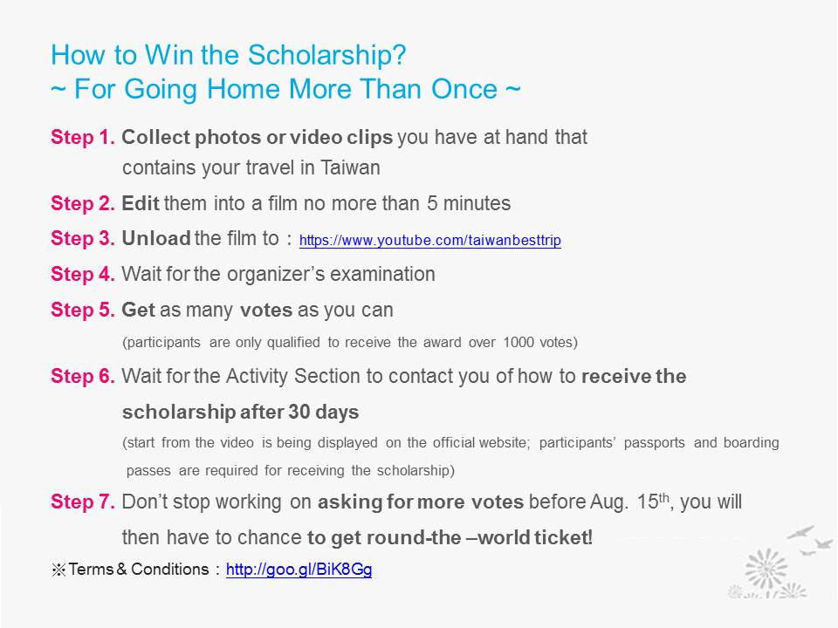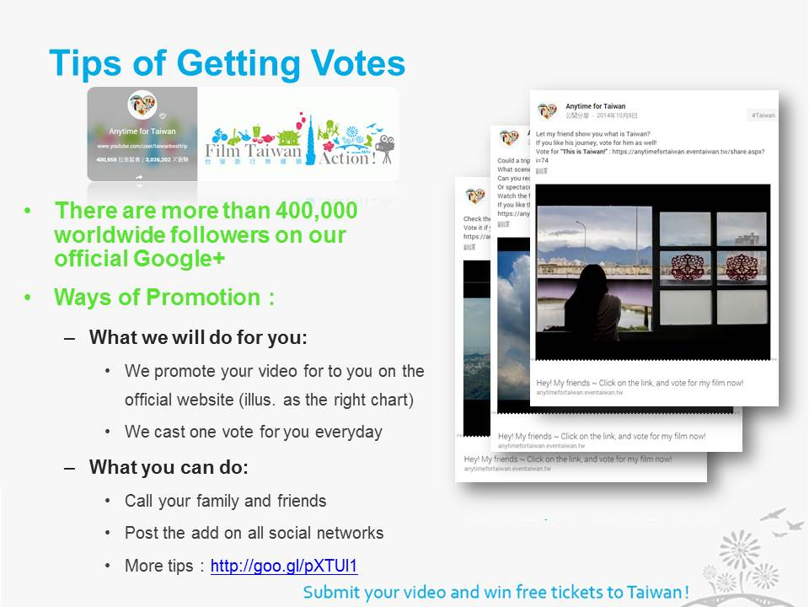

If you have any questions, please write to tbroc.taiwanbesttrip@gmail.com. We will reply you once we receive your email.

Best,
Activity Section

